**WEB PROGRAMMING**

**ASSIGNMENT 1**

**NAME : ADNAN AHMED**

**ROLL NUMBER: 17K3615**

**DATE OF SUBMISSION:**

**6 OCTOBER 2020**

**LIVE URL: https://03162828237.000webhostapp.com/**

**ASSIGNMENT STATEMENT**

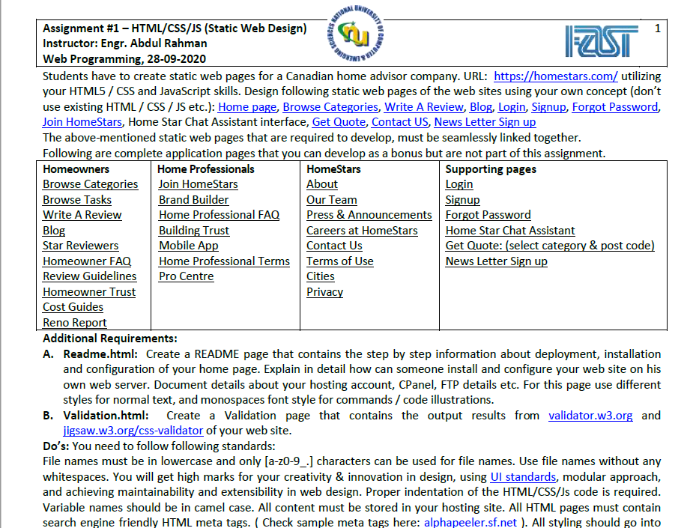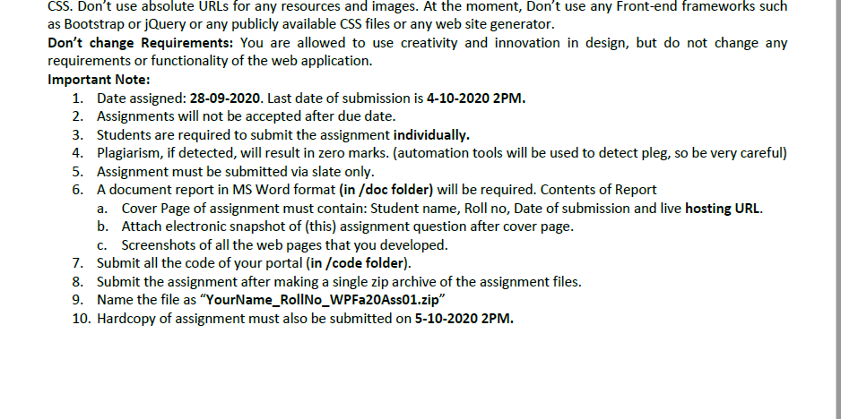

**WEBSITE SCREENSHOTS**

**HOME PAGE**

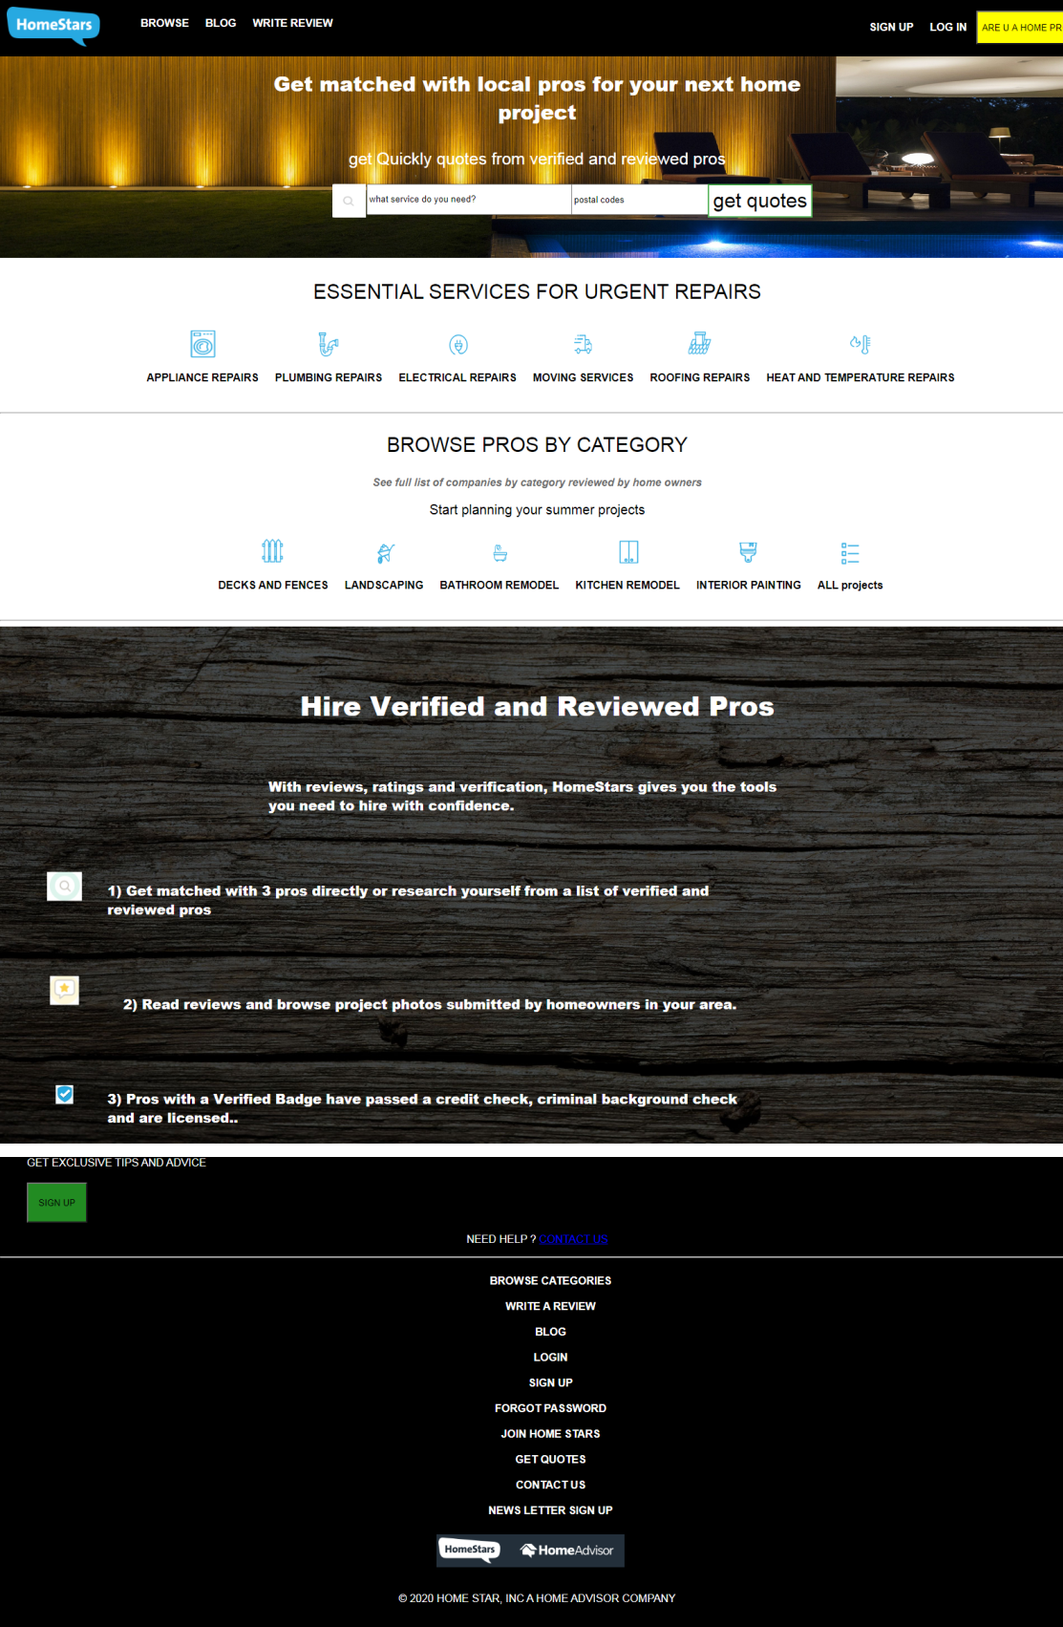

**BROWSE CATEGORIES**

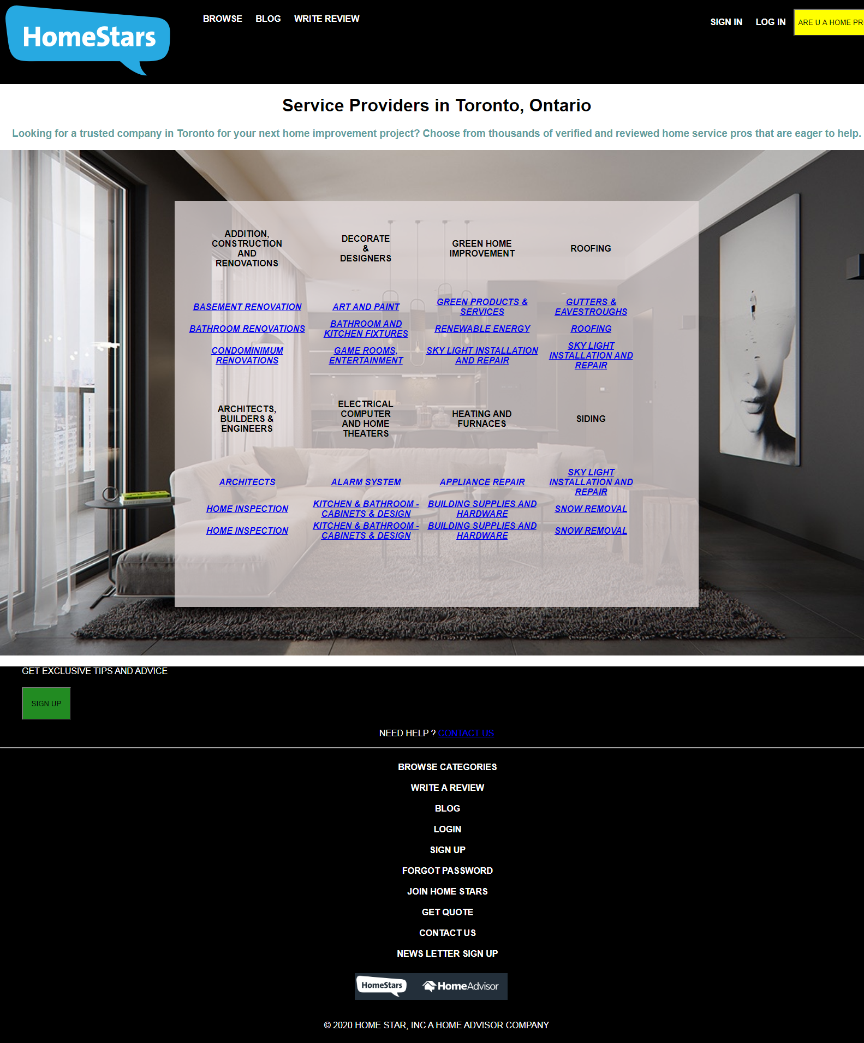

**BLOG**

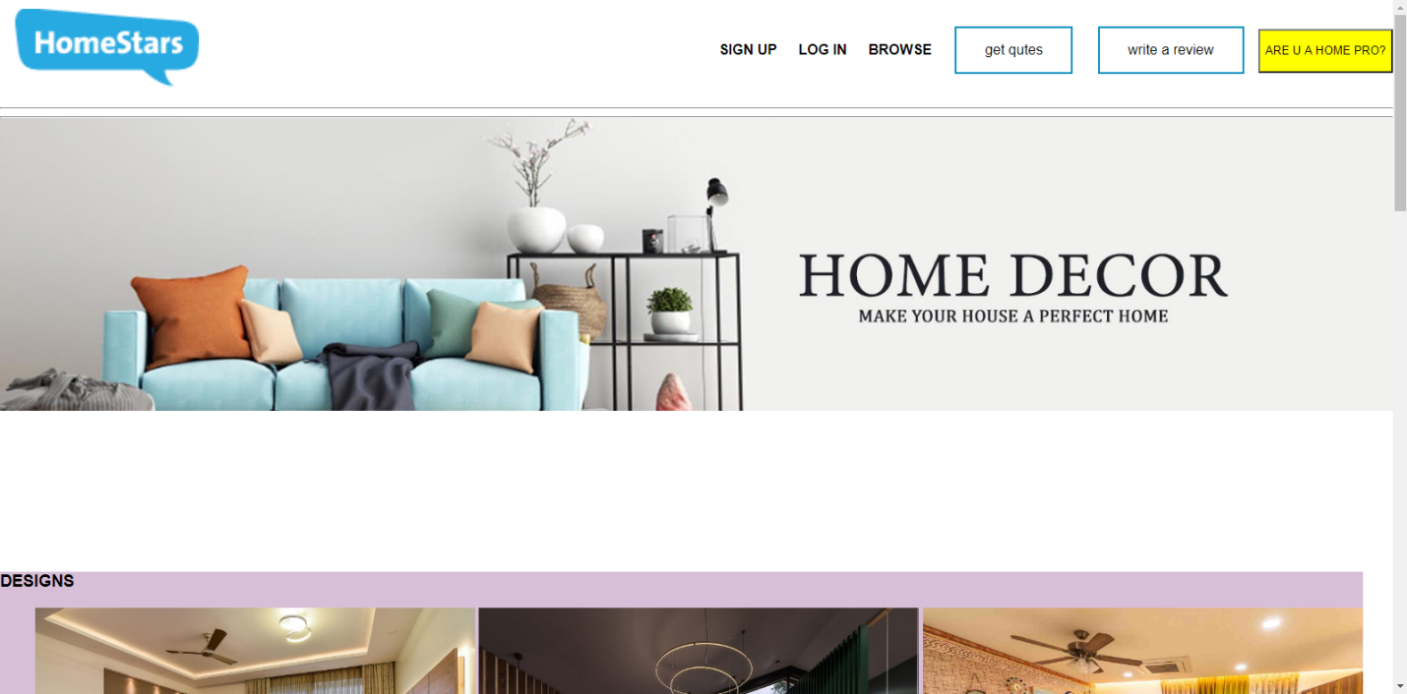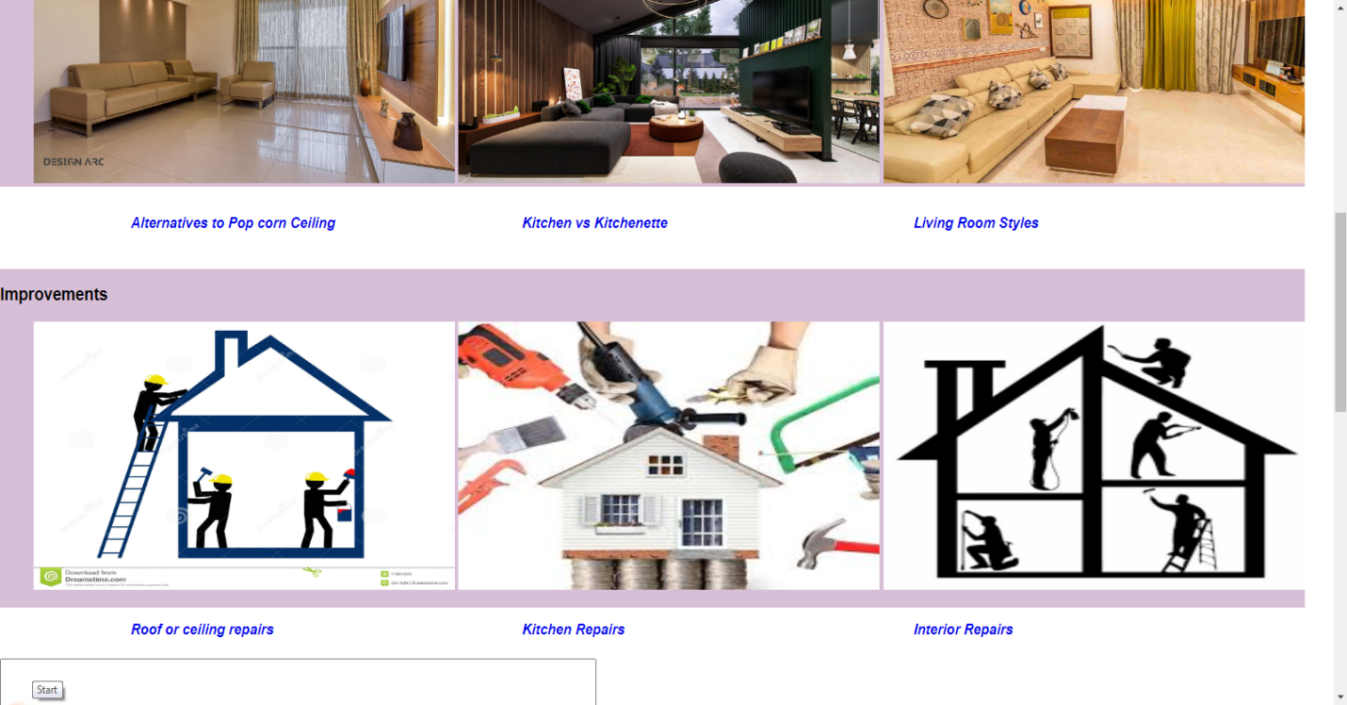

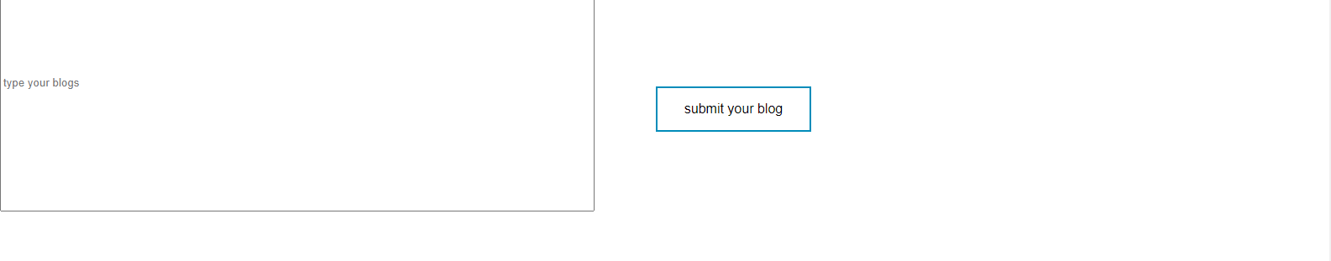

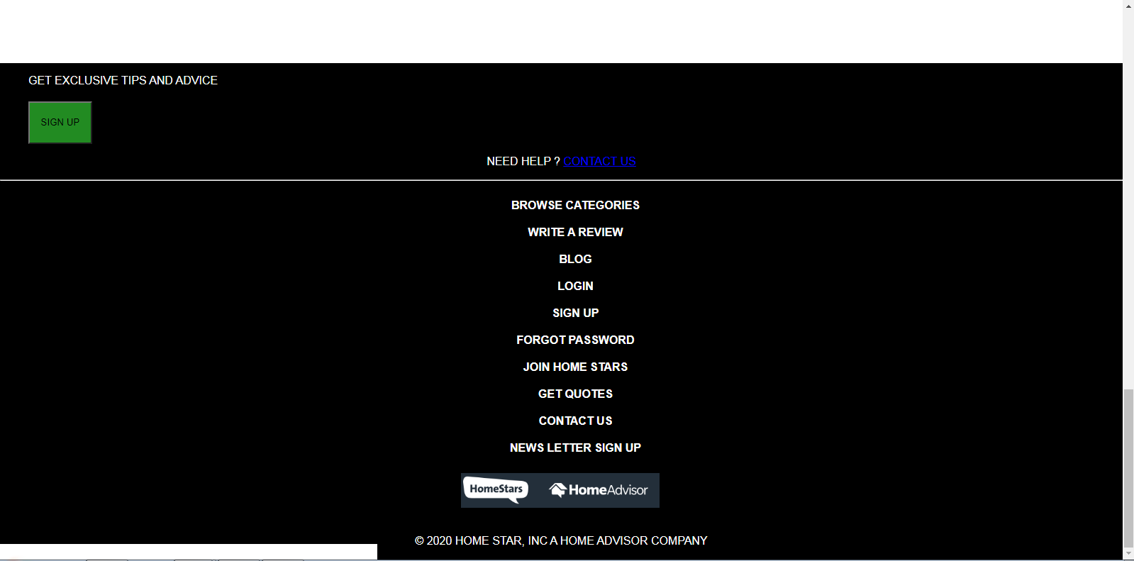

**LOGIN**

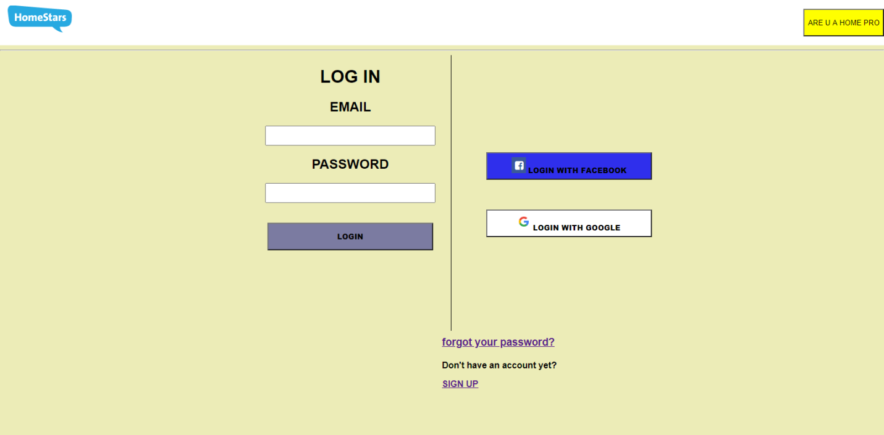

**SIGN UP**

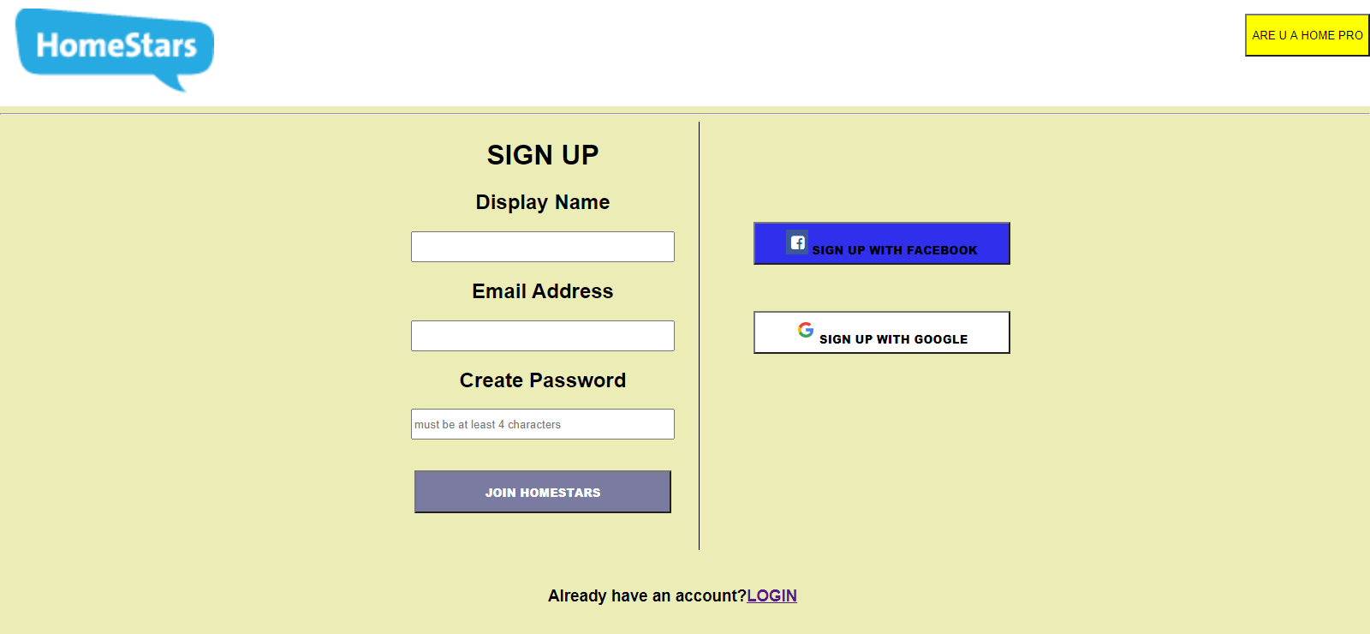

**FORGOT PASSWORD**

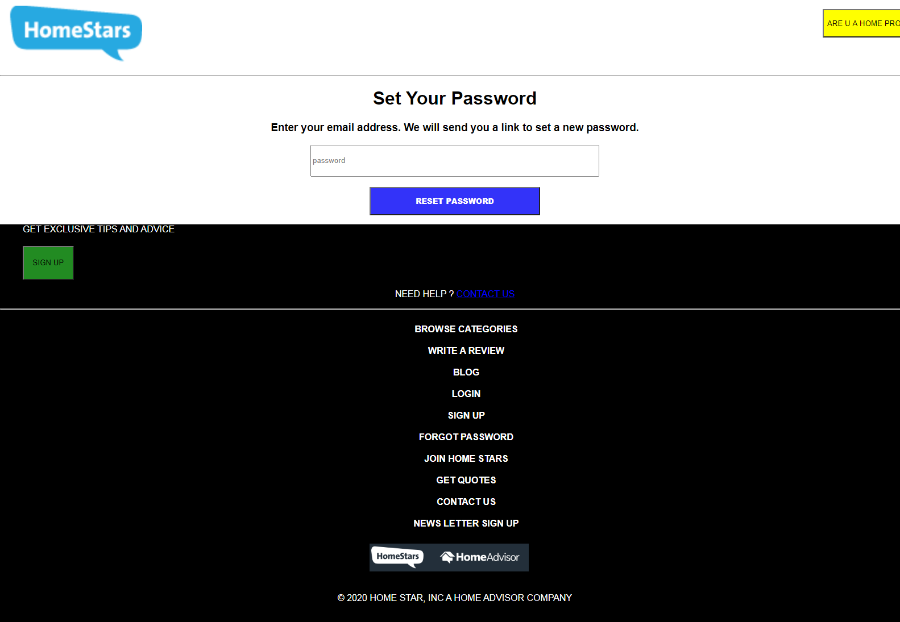

**JOIN HOME SATRS**

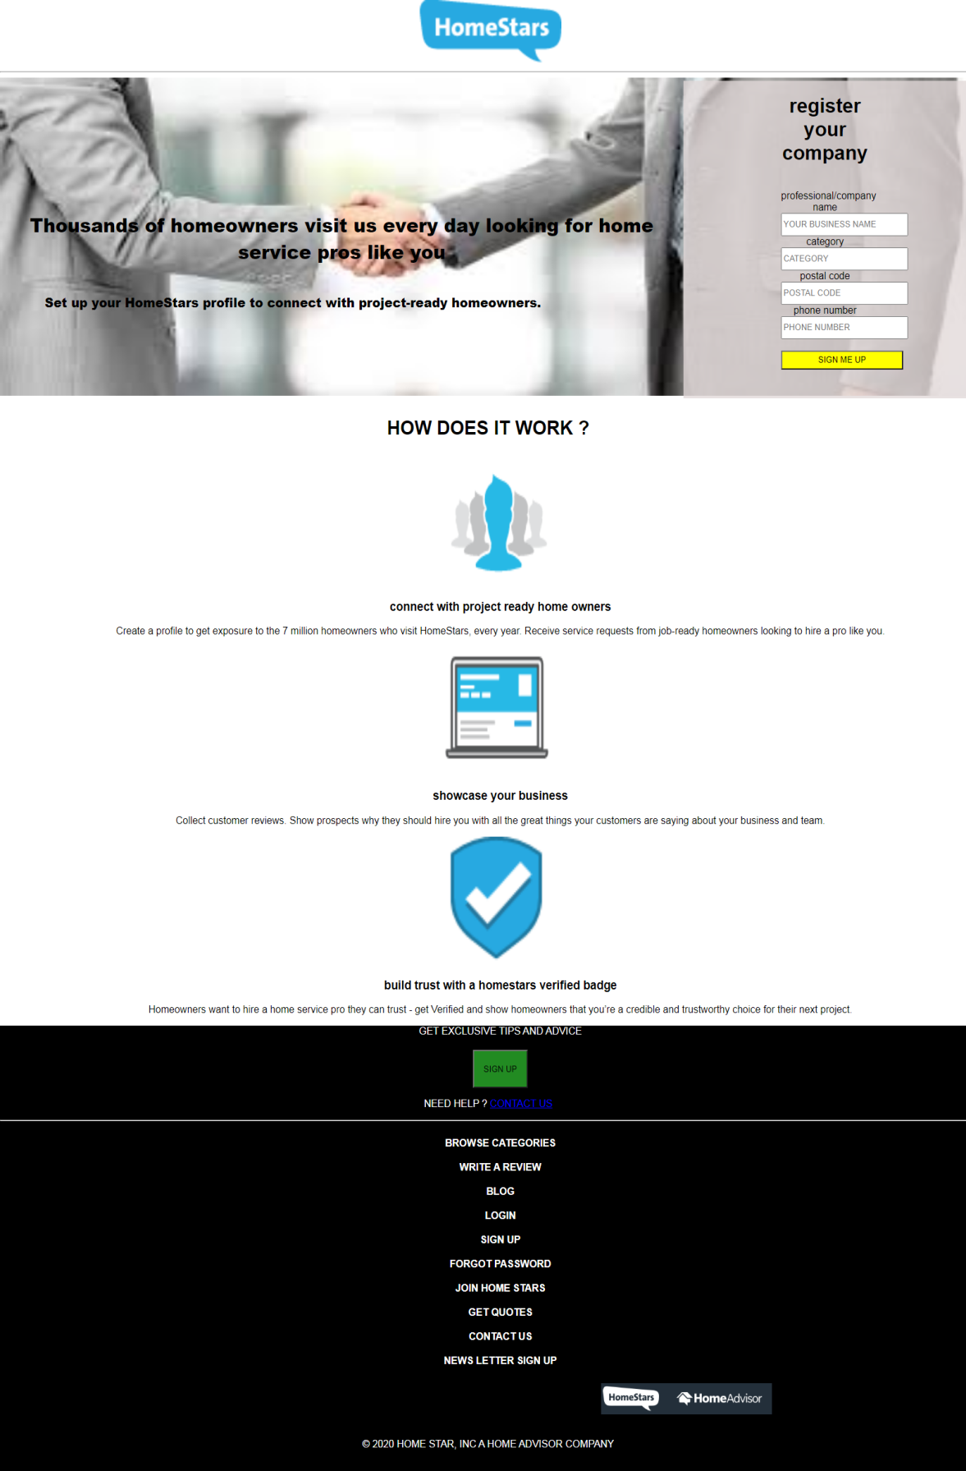

**GET QUOTES**

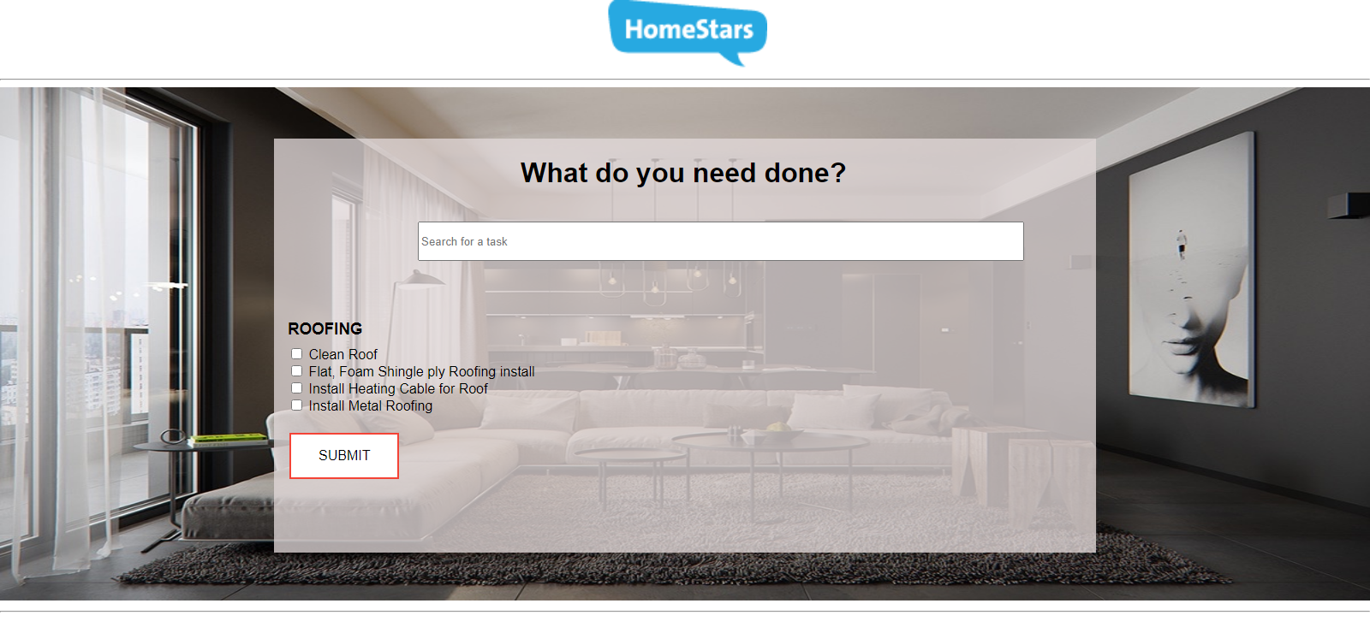

**CONTACT US**

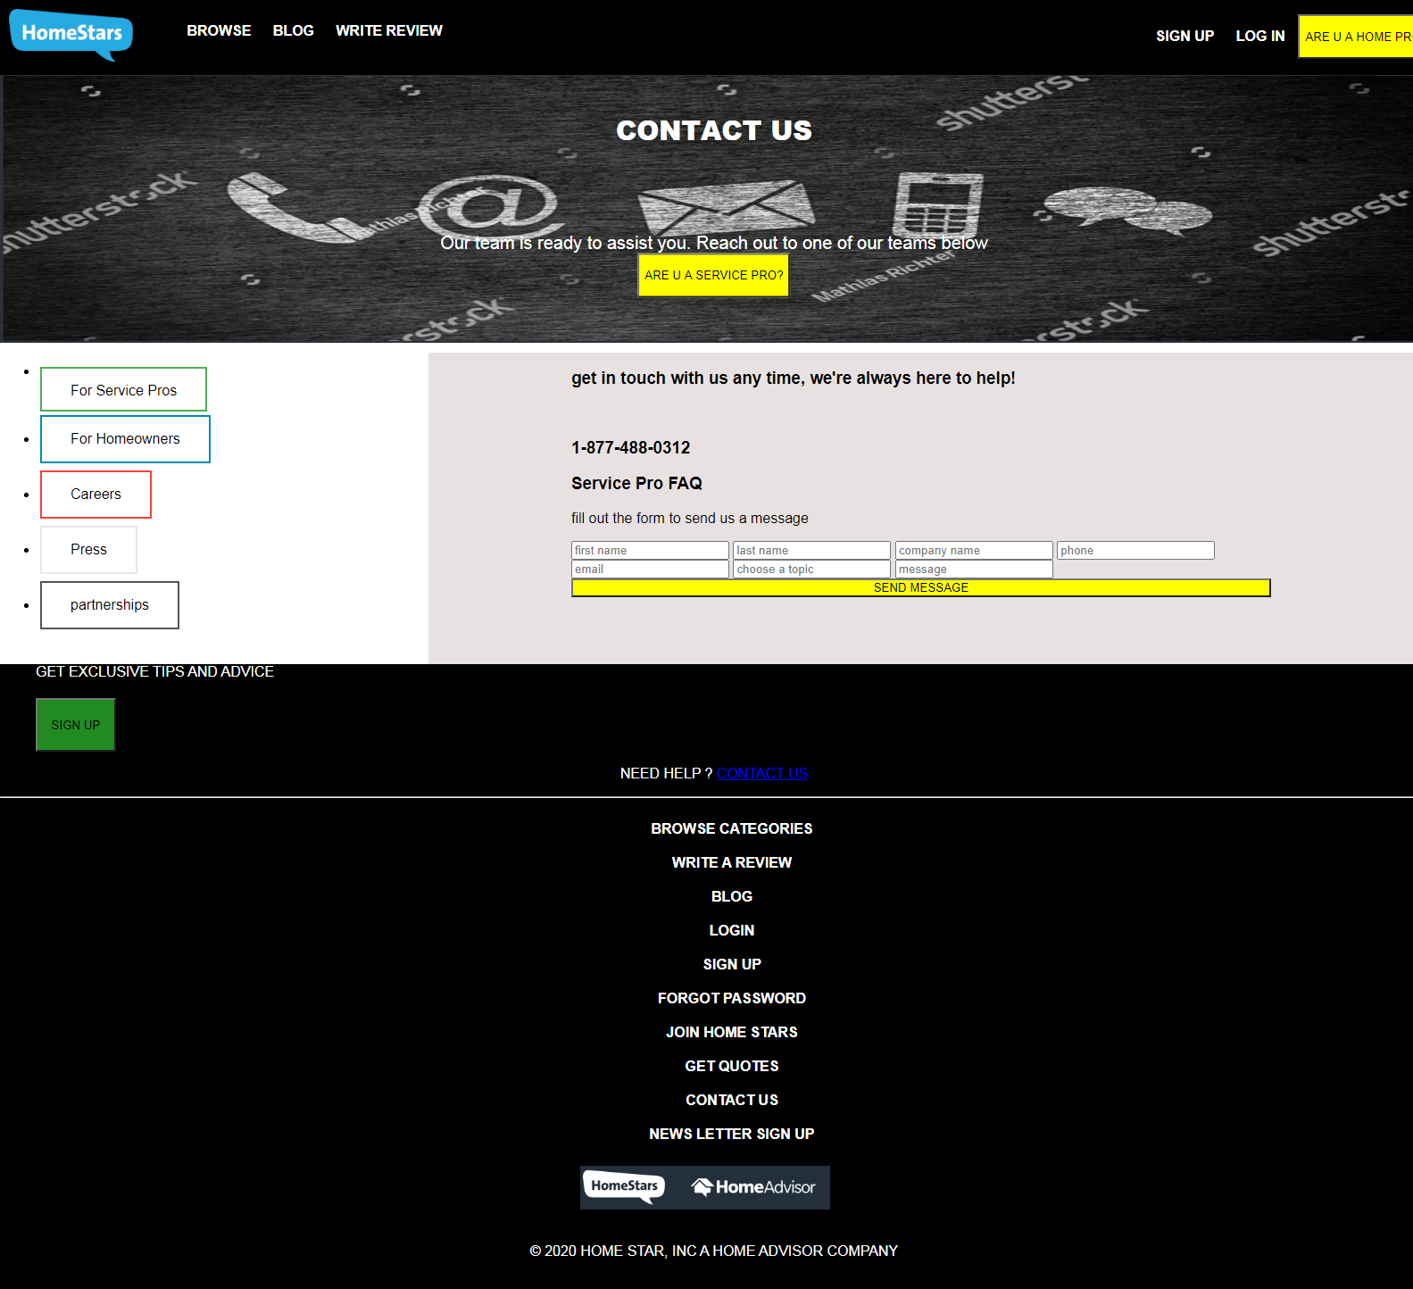

**WRITE A REVIEW**

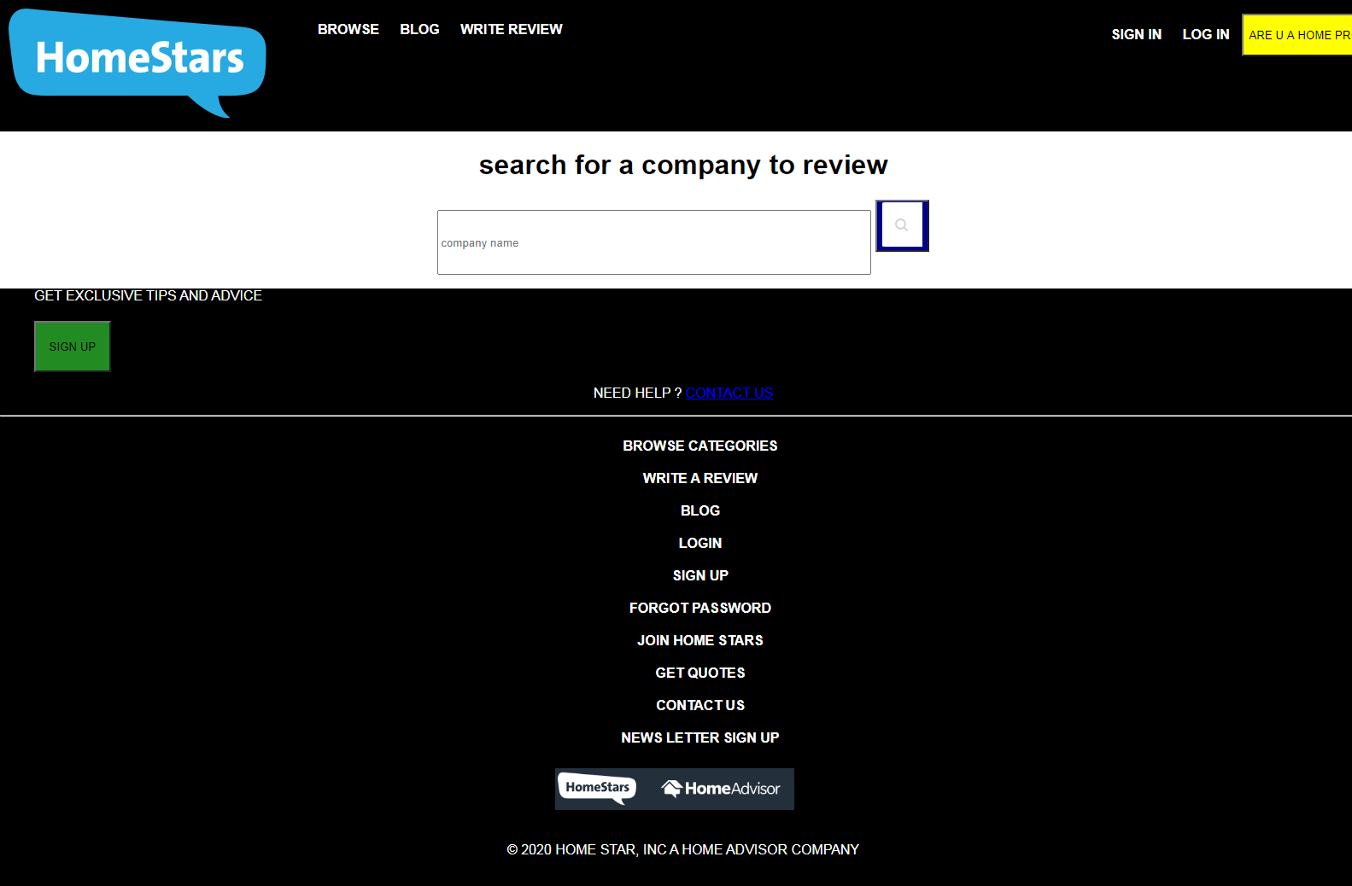

**NEWS LETTER SIGN UP**

